DSA 0601 - Data handling and visualization
Set 6 - Product Sales Analysis

Name : B.Jahnavi
Reg.no:192325043

- Grouped Bar Chart
Code:

library(ggplot2)
library(tidyr)
sales_data <- data.frame(
Product_ID = c(1, 2, 3),
Product_Name = c("Product A", "Product B", "Product C"),
January = c(2000, 1500, 1200),
February = c(2200, 1800, 1400),
March = c(2400, 1600, 1100)
)
sales_long <- pivot_longer(
sales_data,
cols = c(January, February, March), names_to = "Month",values_to = "Sales")
ggplot(sales_long, aes(x = Product_Name, y = Sales, fill = Month)) +
geom_bar(stat = "identity", position = "dodge") +
labs(
title = "Product Sales Analysis - Q1",
x = "Product",y = "Sales",
fill = "Month") + theme_minimal()

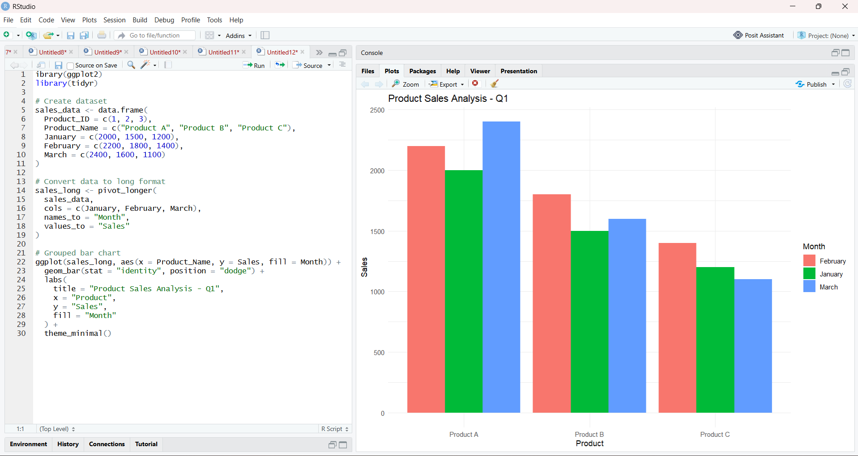

- Stacked Area Chart
Code:

library(ggplot2)
library(tidyr)
sales_data <- data.frame(
Product_ID = c(1, 2, 3),
Product_Name = c("Product A", "Product B", "Product C"),
January = c(2000, 1500, 1200),
February = c(2200, 1800, 1400),
March = c(2400, 1600, 1100)
)
sales_long <- pivot_longer(
sales_data,
cols = c(January, February, March),
names_to = "Month",
values_to = "Sales"
)
sales_long$Month <- factor(
sales_long$Month,
levels = c("January", "February", "March")
)
ggplot(sales_long,aes(
x = Month, y = Sales,
fill = Product_Name,
group = Product_Name
)
) +
geom_area() +
labs( title = "Overall Sales Trend by Product - Q1",
x = "Month",
y = "Sales",
fill = "Product"
) + theme_minimal()

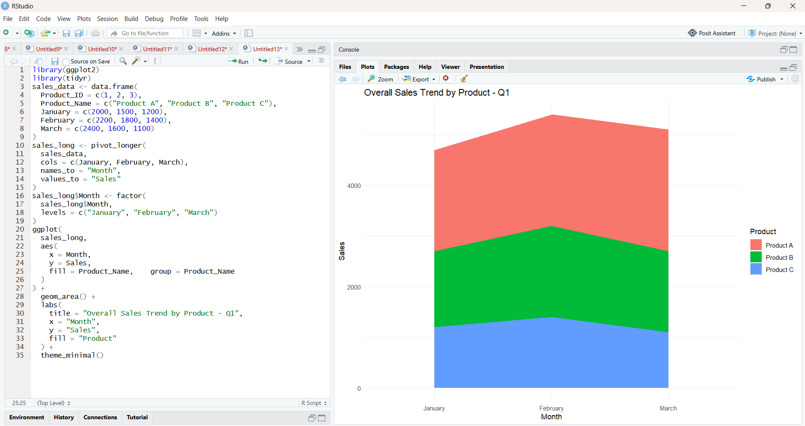

- Monthly Sales Data Table
Code:

sales_data <- data.frame(
Product_ID = c(1, 2, 3),
Product_Name = c("Product A", "Product B", "Product C"),
January_Sales = c(2000, 1500, 1200),
February_Sales = c(2200, 1800, 1400),
March_Sales = c(2400, 1600, 1100)
)

# Display table
print(sales_data)

# Calculate monthly totals
January_Total <- sum(sales_data$January_Sales)
February_Total <- sum(sales_data$February_Sales)
March_Total <- sum(sales_data$March_Sales)

# Display totals
cat("January Total Sales:", January_Total, "\n")
cat("February Total Sales:", February_Total, "\n")
cat("March Total Sales:", March_Total, "\n")

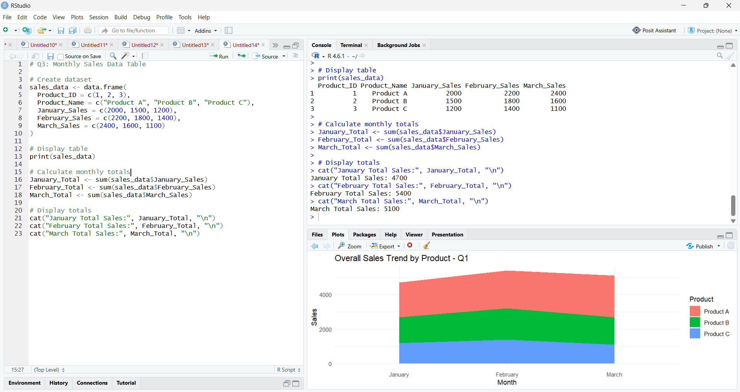

- Tableau Dashboard
Code:
sales_data <- data.frame(
Product_ID = c(1, 2, 3),
Product_Name = c("Product A", "Product B", "Product C"),
January = c(2000, 1500, 1200),
February = c(2200, 1800, 1400),
March = c(2400, 1600, 1100)
)

# Save data as CSV
write.csv(
sales_data,
"Product_Sales.csv",
row.names = FALSE
)

print("Product_Sales.csv created successfully!")

